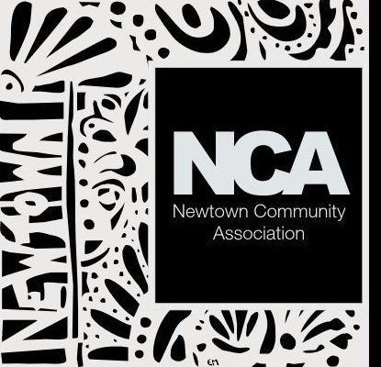Newtown Community Association (Exeter, Devon)

Membership Form

First Name: Click or tap here to enter text.

Surname: Click or tap here to enter text.

Address line 1: Click or tap here to enter text.

Address line 2: Click or tap here to enter text.

Address line 3: Click or tap here to enter text.

Postcode: Click or tap here to enter text.

Email: Click or tap here to enter text.

Telephone: Click or tap here to enter text.

I agree to these details being stored by Newtown Community Association

Signature: _________________________

(Note – if this form is submitted by email, the email signature is sufficient)

Date: Click or tap to enter a date.

Please email this form to [secretary@newtowncommunity.org.uk](mailto:secretary@newtowncommunity.org.uk)

Or post to: NCA Secretary

Newtown Community Centre

Belmont Park, Belmont Road

Exeter EX1 2HQ

Newtown Community Association (Exeter Devon)

UK registered charity, number 1173331 see <http://www.charity-commission.gov.uk/>

<http://newtowncommunity.org.uk/>